Answer 1
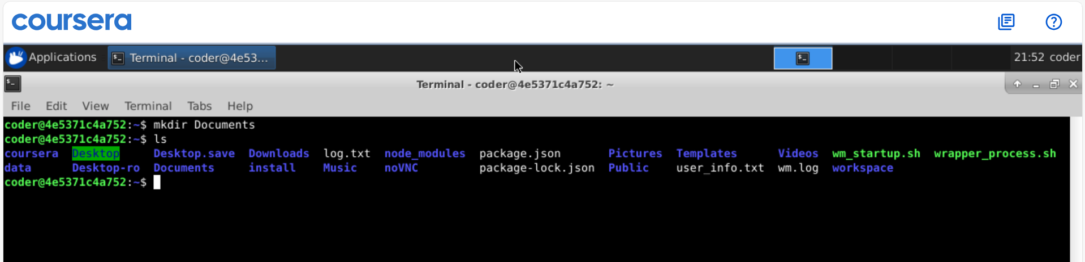
Explanation: Using mkdir Documents command we created a directory name Documents in the home directory. As I am already in my home directory so didn’t uses ~ but if I am at any other place we can use mkdir ~/Documents to create directory inside home directory.
Answer 2
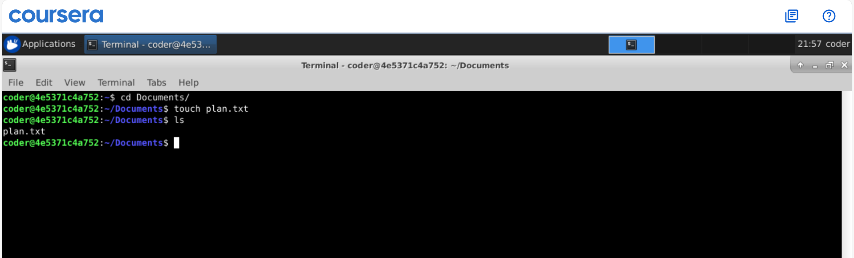
Explanation: As asked, I went to Documents directory using cd command and created a plan.txt text file using touch command. Now instead of using many commands we can do all this in 1 line touch ~/Documents/plan.txt
Answer 3
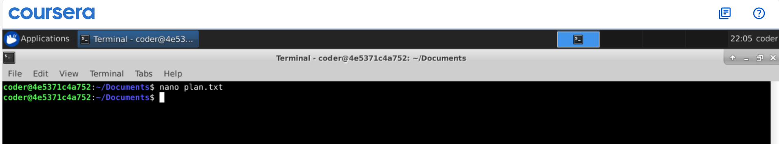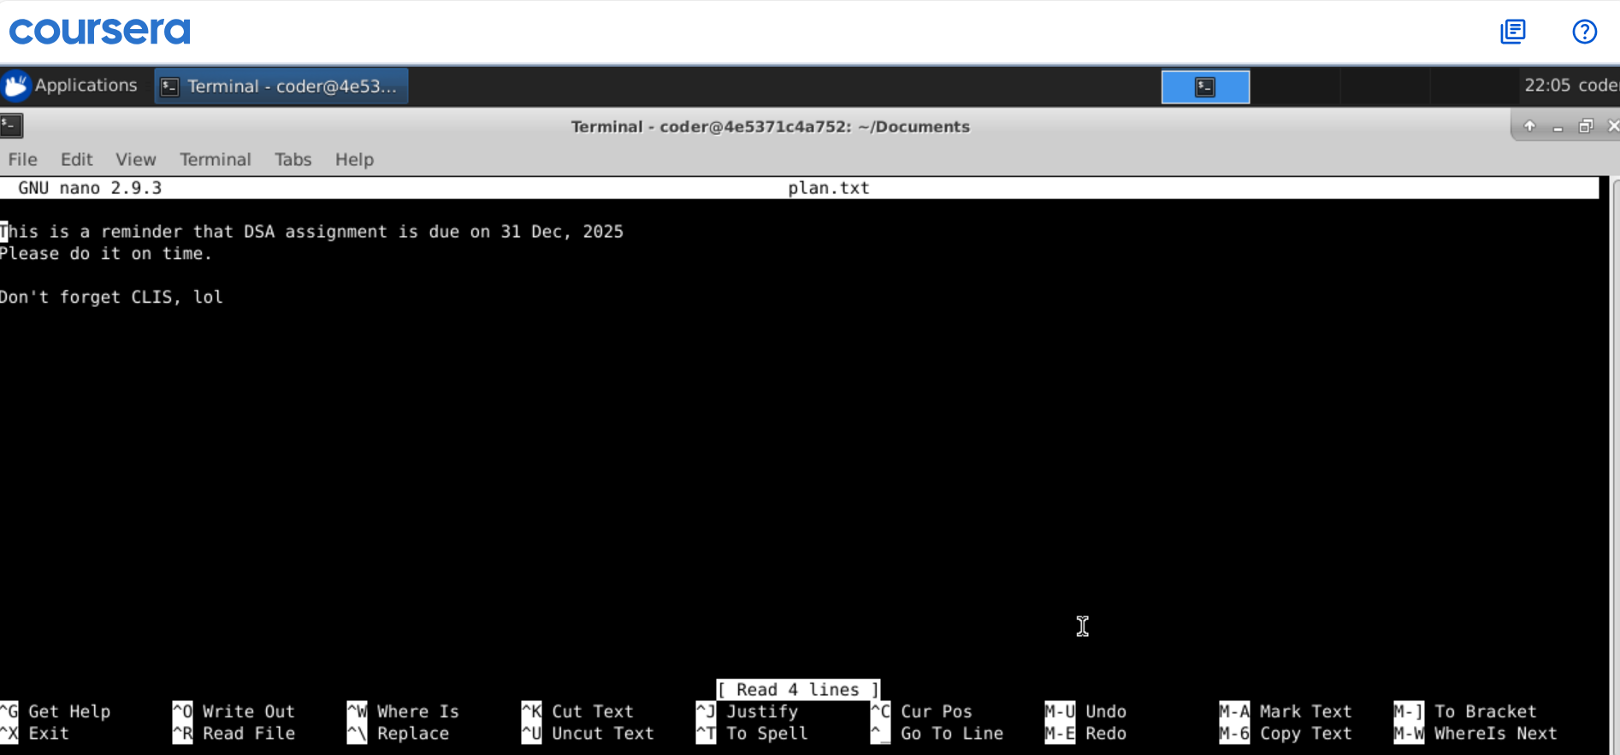
Explanation: I have added text using nano paln.txt command, it can be also done using vi text editor with vi plan.txt command. Also, we could use echo “Text here ” >> plan.txt.
Answer 4
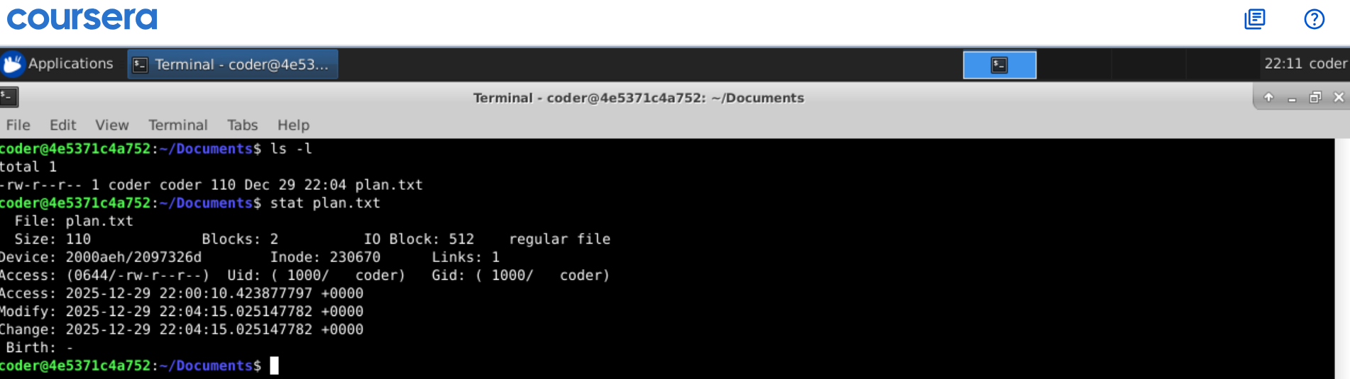
Explanation: This can be done by many ways but I will explain 2 commands ls -l will show username and all the permission. Another command is stat with file name will show all info regarding file includes many things,
Answer 5
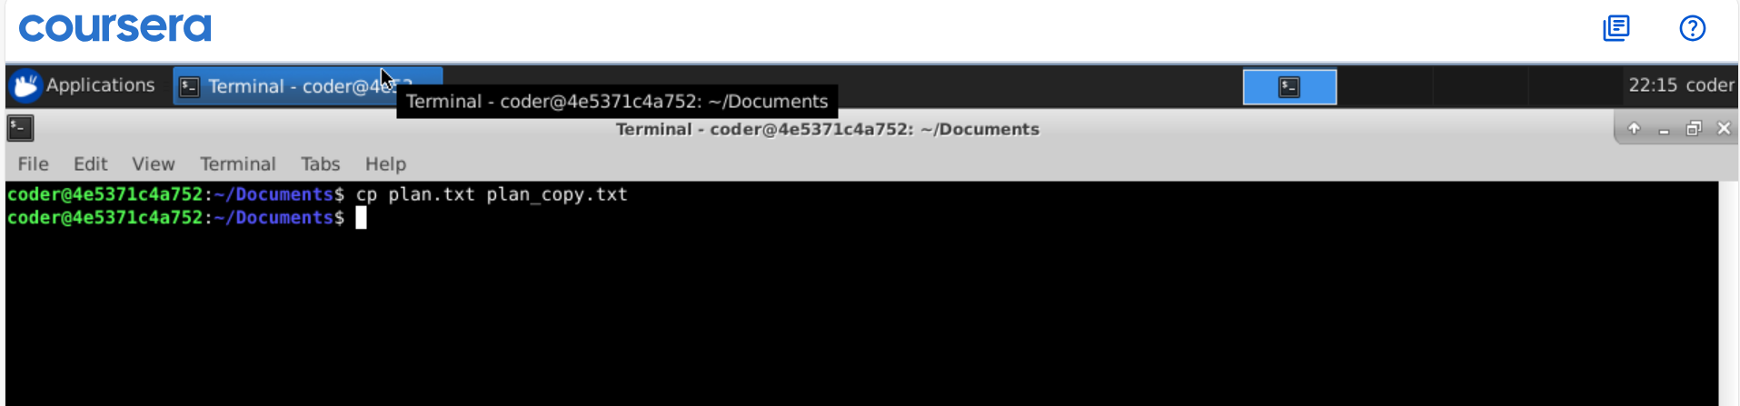
Explanation: By using cp command, we can copy a file. The syntax would be cp source_file new_file.
Answer 6
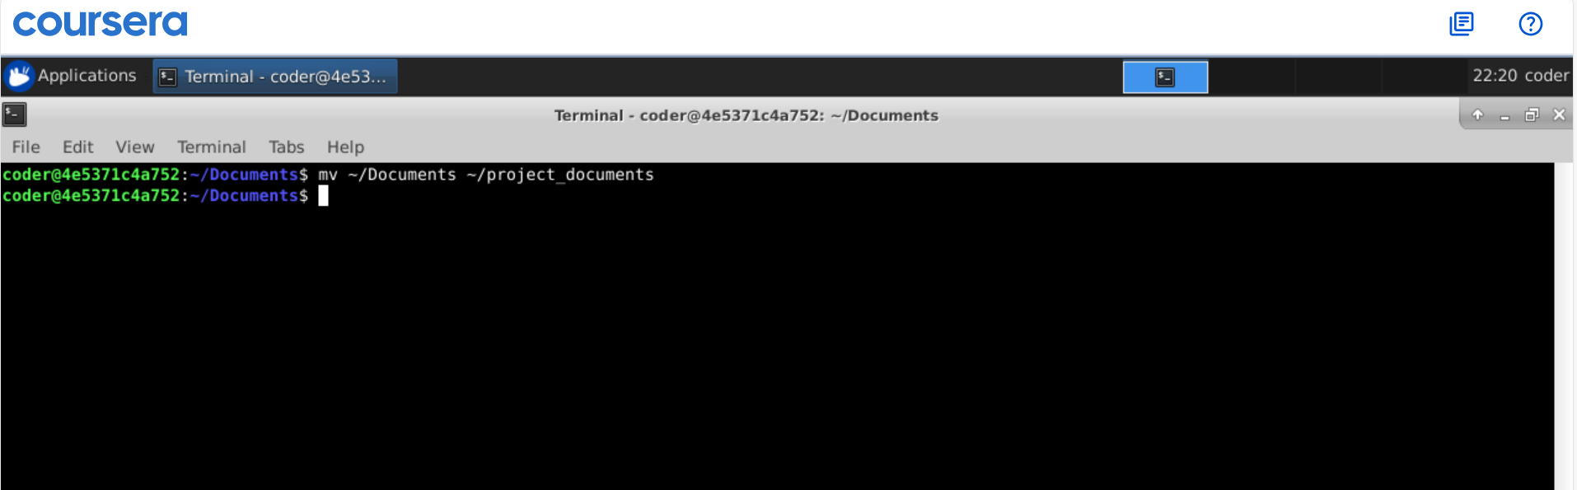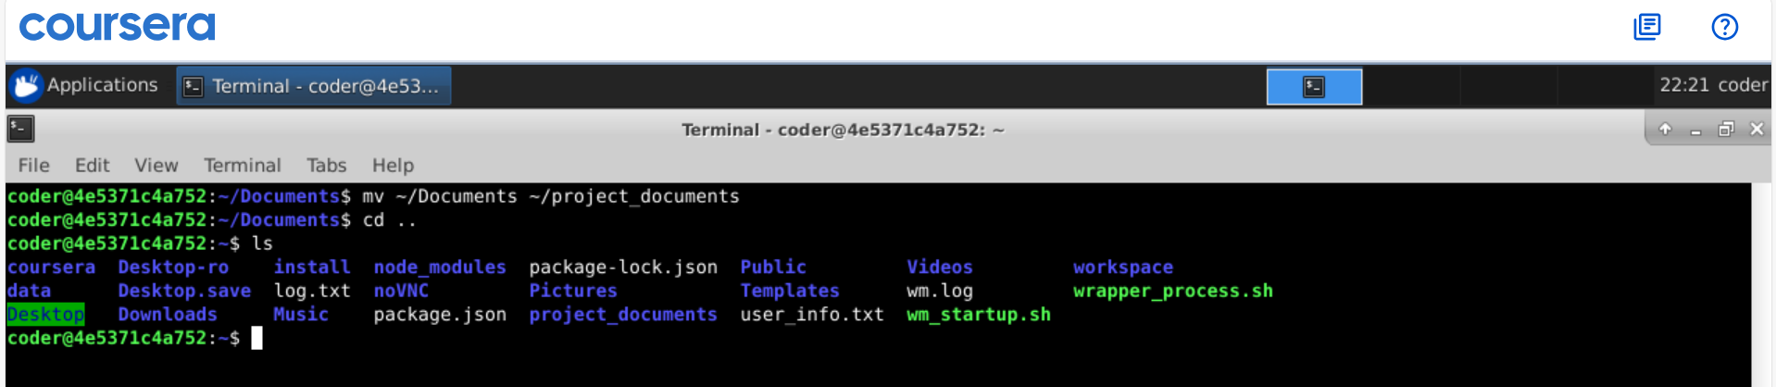
Explanation: we can use mv command to move file but at the same time we can use this command to rename a file without changing its content.
Answer 7
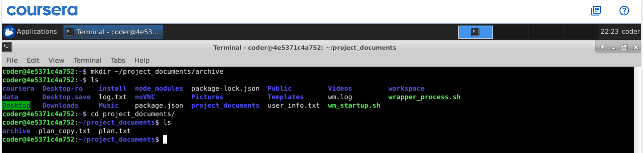
Explanation: Again using mkdir command we can create a directory and by providing the patch it can go as desired. Also, by using -p option we can create parent and subdirectories in 1 line.
Answer 8
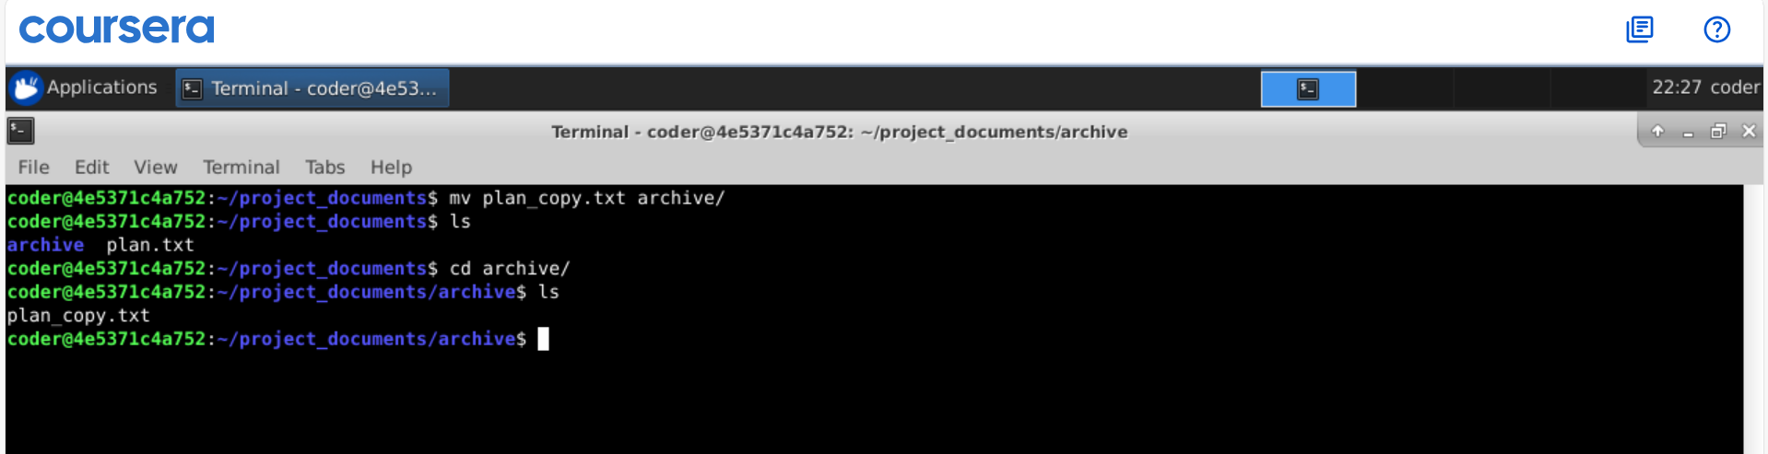
Explanation: Using mv command we can move a file from one directory to another that what I did with plan_copy.txt and it gives desired output.
Answer 9
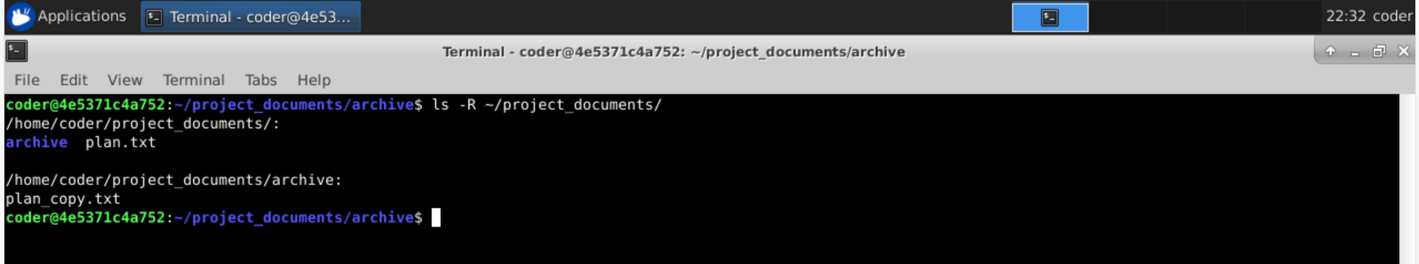
Explanation: By using ls with -R option will show us the all files and directory inside a directory recursively.

Answer 10
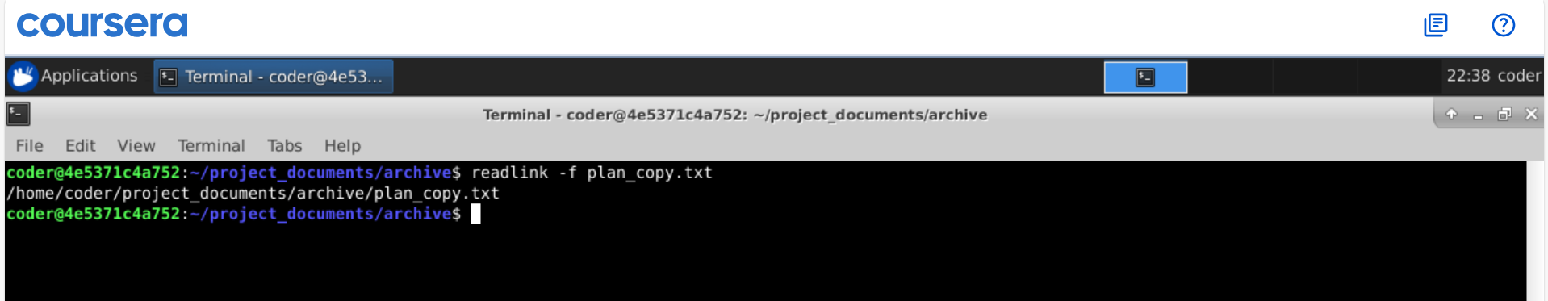
Explanation: So readlink command with -f option shows the absolute patch to the file. But for this we need to be in the file location else we need to provide the patch to the file.

